Brennan Metzelaar & Joshua Nuez

Pete Tucker

CS 372

16 January 2015

Specification UML

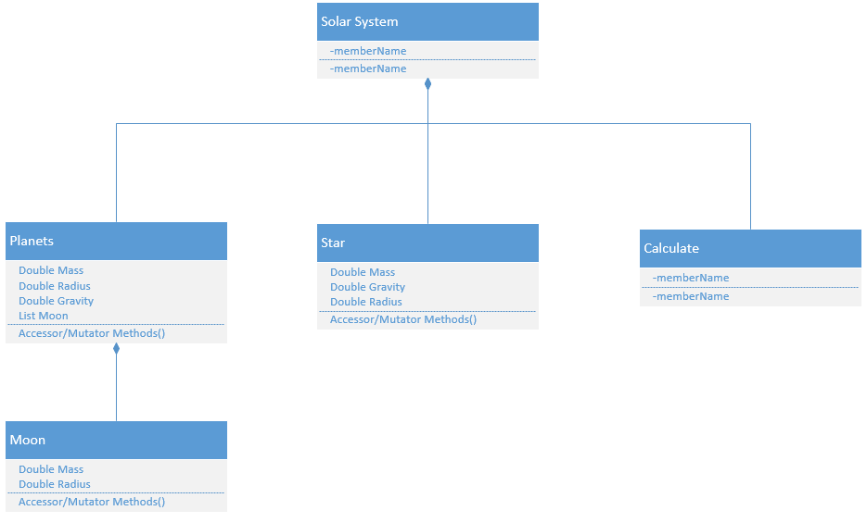

The initial UML diagram is fairly simple because we aren’t fully sure on the specific Calculate functions we will need or how many objects we want to simulate in our solar system. For example, we may add different types of stars that would inherit from Star. Until we know how much we are calculating on the physics side of this program, the scope of the project is a little uncertain.